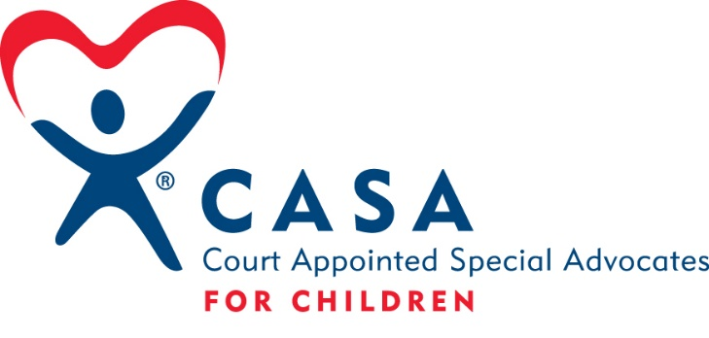
What is CASA?
CASA stands for Court Appointed Special Advocates. CASA Volunteers are not paid for their time; they are trained volunteers. Judges determine to which case a CASA Volunteer may be assigned. The CASA Volunteer’s role is to gather information about the child and write reports to the court on their findings. The information is used to help the Judge make informed decisions in the child’s best interests.
The CASA Volunteer:
does not investigate why DHHS opened a case or attempt to prove guilt or innocence.
does not provide child care for the children.
does not provide you with information about the parents or relatives of the children.
does not act like a parent or a big brother/big sister to the children.
does not decide what happens with the children’s case. That is up to the Judge.
does not act as a counselor or a friend to anyone involved in the case.
does not choose sides or align themselves with others in case disagreements.
does not make promises to you or the children in your care.
does not work under the direction of any other professionals involved in the case.
does not represent anyone other than the child in court or give legal advice.
The CASA Volunteer:
does talk to people who might have information about the children. This will include teachers, doctors, foster parents, therapists, social workers and all others who have information about the children.
does get to know the children in your care and will visit them one-on-one at least once a month.
does get to know you and can help you find and use resources in the community to meet the children’s needs.
does take notes about the health and welfare of the children in your care and reports this to the court and other professionals working on the case.
does need to be informed of all school meetings, to include IEPs and other educational meetings regarding the children.
does listen to your thoughts and concerns about the children in order to best advocate for them.
does remain objective and reports on the facts of the case.
does attend all Dependence & Neglect hearings in the case and represents the child.
does maintain a professional level of confidentiality.

YOU CAN CALL US AT 308-995-2102 IF YOU HAVE ANY QUESTIONS ABOUT CASA.
Phelps/Harlan County CASA Kelly Jensen, Executive Director
715 5th Ave. Suite 6, Holdrege, NE 68949 Phone: 308-995-2102 Fax: 308-248-5090
e-mail: casa@phelpscone.org

